MINISTRY OF HEALTH & MEDICAL SERVICES
PRIMARY TRAUMA CARE COURSE Kiribati
23rd – 27th June, 2015

Table of Contents

- Introduction …….……………………………………………………………………………………………………………2

- PTC Instructors’ Refresher Course …………………………………………………………………………………3

- PTC Providers’ Course
  - Tungaru Central Hospital Courses .…………………………………………………………………………..4
  - Betio Hospital Courses …………………………………………………………………………………………….6
  - South Kiribati Hospital Course ..………………………..……………………………………………………12

- Recommendation ………………………………………………………………………………………………………..14

Conclusion……………………………………………………………………………………………………………………15

INTRODUCTION

Primary Trauma Care (PTC) Course was developed to train local health personnel in prioritizing and treating the severely injured patients quickly and systematically using available resources, thus reducing death and disability.

Trauma is a leading cause of premature death and disability in Kiribati as is the case in many developing countries. Motor vehicle accidents, violence and falls are the main causes of injury presenting to the two main hospitals (Nawerewere and Betio) on both ends of the main island of Tarawa, as well as the South Kiribati Hospital.

A regional workshop was held in Nadi, Fiji, from April 20 – 24th 2015. The PTC Instructor Master Class aimed to update the pedagogic skills of the PTC Instructors from 8 Pacific Island Countries (PICs). Drs Kabiri Tuneti and Alani Tangitau attended this forum which provided an opportunity to introduce the new 2015 PTC Instructors Manual and to share and exchange recent teaching experiences from around the Pacific region. As a result of this forum, Kiribati PTC Coordinating Team plan for this PTC courses for Kiribati. (Attachment 1 – PTC course schedule)

Kiribati PTC Coordinating Team

The members for this team are;
- Dr Kabiri Tuneti – General Surgeon Tungaru Central Hospital (TCH)
- Dr Tekeua Uriam – Anaesthetist (Final Year MMed Trainee)
- Dr Hilda Schutz – Anaesthetist (2nd Year MMed Trainee)
- Dr Alani Tangitau – Anaesthetist (KITP Supervisor)

The local coordinating team organized for the PTC courses including the assistance from KITP Program Assistant, Odylia Teaero, who has been magnificent with arranging and providing assistance to all our teams.

Plan

- Invite 3 external instructors (Dr Desmond (PNG), Dr Deepak Sharma (Fiji), Dr Hilda Schutz (I-Kiribati Postgraduate Trainee in FNU) to join our local team (Drs Kabiri, Tekeua and Alani) to facilitate the courses.
- Conduct an Instructors Refresher Course on the first day – participants will be from doctors and nurses who have done the PTC Provider and Instructors course in the last 2 years.
- Divide the instructors in 3 teams – Betio team, TCH team and SKH team where we will run courses in these 3 hospitals simultaneously.
- Betio Hospital and TCH, both in Tarawa, will have 2 courses and South Kiribati Hospital will have 1 course since the team have to travel from Tarawa to Tebteuea (outer island)
- Target participants were : doctors, nurses, medical assistant and final year trainee nurses from the Kiribati School of Nursing
- Funding for these courses was shared by the Kiribati Internship Training Program (KITP), WHO and the Ministry of Health and Medical Services (MHMS).

PTC INSTRUCTORS’ REFRESHER COURSE

The main aim for this Instructors’ course is to build local capacity for PTC instructors in order to sustain PTC courses delivery in Kiribati.

There were 10 participants were nominated to attend this Instructors course, 4 Doctors, 3 Senior Emergency Nurses and 3 Tutors from the Kiribati School of Nursing (KSON). Unfortunately, one of the KSON Tutors did not attend due to family reasons. (Attachment 2 – Instructors Participants List)

We have 6 facilitators for the Instructors Course;
- Dr Desmond Aisi : Emergency Physician, PNG
- Dr Deepak Sharma : Emergency Physician, Fiji
- Dr Hilda Schutz : I – Kiribati 2nd year MMed Trainee (Anaesthesia)
- Dr Kabiri Tuneti : General Surgeon, TCH, Kiribati
- Dr Tekeua Uriam : I – Kiribati Final year MMed Trainee (Anaesthesia)
- Dr Alani Tangitau : KITP Supervisor, Anaesthesia

Program for the course as per attached (Attachment 3 – Instructors’ Course Program)

At the end of the course, 9 instructors were satisfactorily pass and provided with their certificate.

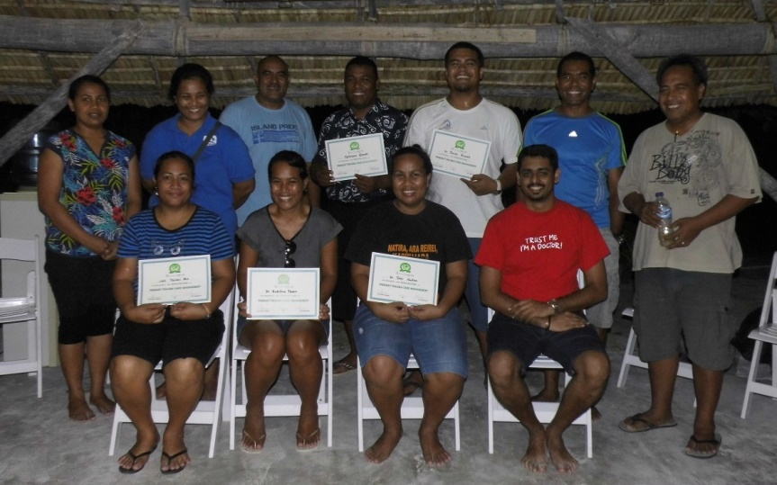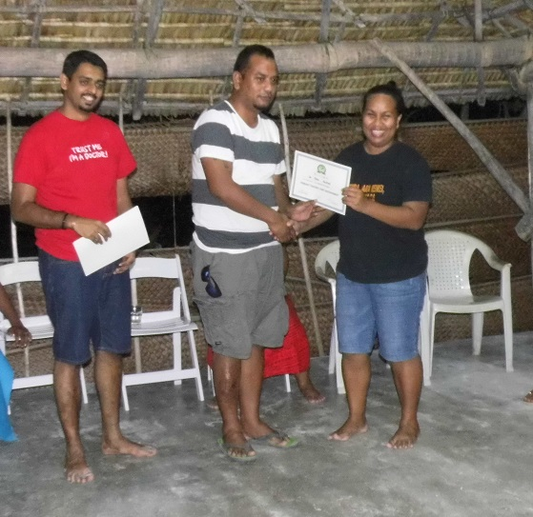

I – Kiribati PTC Instructors that were presented with their certificates by the Permanent Secretary for Health, Dr Teatao Tiira, at the MHMS Retreat at the Tabontekeke Resort

At the completion of the PTC Instructors Course, Kiribati has 13 qualified PTC Instructors which we divided into 3 teams for the courses in Betio Hospital, TCH and South Kiribati Hospital.

PTC PROVIDERS COURSE

TUNGARU CENTRAL HOSPITAL COURSES

Report compiled by Dr Deepak Sharma

Instructors :
Drs Deepak Sharma, Tekeua Uriam, Kabiri Tuneti, Thomas Russell, Bukitua Teuea, SNO Teiraoi Bio

A group of PTC Instructors (1 from Fiji, 2 existing local and 3 newly trained) conducted the two sets of Primary Trauma Care course at the Tarawa Central Hospital (TCH).
Having completed the Instructor course a day prior, the new instructors were quite energetic and rose up to the challenge of delivering the provider course.
The course topics and skills stations were divided amongst the 5 Instructors, and the course was delivered primarily in English language, however the vernacular was also used to allow better and quicker understanding amongst the participants.
The course materials were provided through the Kiribati Internship Training Program (KITP) and a manikin was also brought by the team from FNU CMHNS Suva, Fiji.
Moreover, in doing our part in preventing wastage of paper, the TCH team opted to project the multiple choice questions on power point giving a minute per question for both the pretest and the post test.
PTC Provider Course 1 : 24th – 25th June : Doctors & Nurses
Though a total of 20 participants were registered and expected for the first course, a total of 12 participants showed up and completed the course.
This group of participants included 4 medical interns, who had graduated from Cuba and were in the internship program. Also 4 staff nurses and 4 sisters in charges from the emergency department and the surgical wards.
Some of the participants did not have prior access to the course materials, and so the initial lectures did not have as much interaction as the subsequent ones. Additionally, the use of skill stations scenario demonstrations proved to be beneficial as it ‘broke the ice’ and made participants more interactive in all the further stations.
Also of note was that, several of the participants had scored an average of 7 out of 20 in the pre-course multiple choice questions and an average of 18 out of 20 in the post course multiple choice questions.
The use of both English and vernacular in delivering the course facilitated better learning of the participants and greater acceptance of what was being taught.

PTC Provider Course 2 : 26th – 27th June : Final Year Trainee Nurses
The second provider course was just as exciting as the first. The second group consisted of final year nursing students, from the Kiribati School of Nursing. A total of 20 were registered to participate. In addition, 4 nurses also requested to be part of the second provider course as they were not able to get release for the first one. This was welcomed.
So 24 participants began the course however as the second day was a Saturday, this led to a delay in starting the course on time and furthermore 20 of the 24 participants showed up. Therefore 20 participants completed the second provider course at the TCH.
It was evident that the this group was prepared for the course and had received and gone through their course manuals, as they were very interactive and themselves helped direct the slides lectures allowing the facilitators to dwell more time on points that were not clearly understood.
Moreover, an average of 8 out of 20 was achieved in the pretest and an average of 17 was scored in the post test, with some participants also scoring the full 20.
It was also important for the Instructors to empower this group of participants, as many felt that PTC was primarily for Doctors. However, at the completion of the course, several participants realized the teamwork involved particularly in disaster management and how to work as a team compromising of both doctors and nurses.
All in all another exciting group of participants.
Participants from the first (left) and second (right) provider courses.
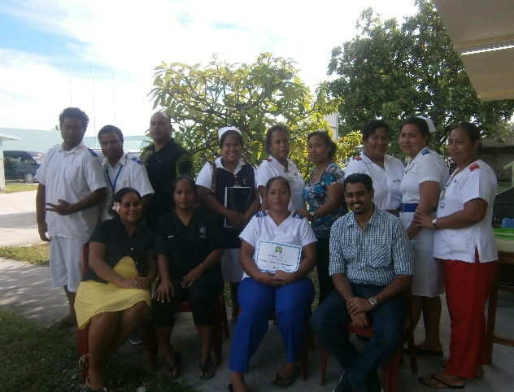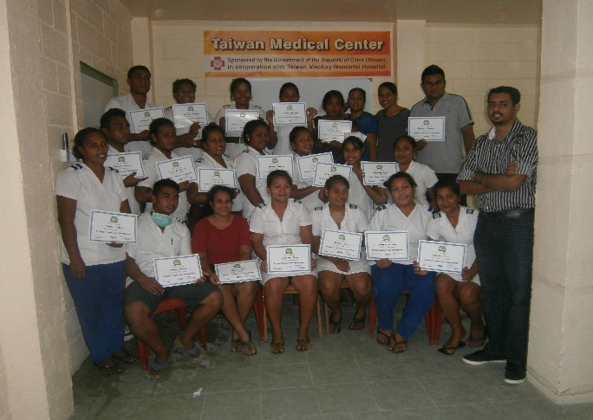

The completion of the two provider courses together with the other three in two other locations was no easy task. However, with the good teamwork and dedication from the local and visiting team this was achieved so effortlessly. It was a particularly enjoyable experience for me and a real honor to be involved in this project.

BETIO HOSPITAL COURSES

Report compiled by Dr Desmond Aisi

- Summary
The PTC courses were delivered to Kiribati. The first day was a refresher course for the Instructors and followed by 5 PTC courses at different times and locations. PTC Betio was run by five (5) instructors led by Dr Desmond Aisi, others being Dr Hilda Schutz,(Anaesthetic Registrar, FNU), Dr Ieita Atanrere’i (Kiribati Hospital) Sr Monica Tarabo, (Lecturer, KSON) and Sr Maile Kiritome ( Lecturer, KSON) who delivered two (2) PTC courses in Betio. The first PTC course was attended by 20 participants all of whom were nursing officers (NO) and was conducted from 24th and 25th June 2015. The second PTC course was attended by 25 participants which comprised of 20 final year Nursing Students and 5 Nursing Officers from 26th and 27th June 2015.
- Introduction
PTC was introduced to Kiribati in 2009. Since then there were a few PTC courses run but due to reasons beyond the local instructors control it was not done on a regular basis, as it was due to, firstly limited number of instructors, funds and logistics to name a few.
- The PTC Betio Team

The team of facilitators and instructors included the following.
Instructors
1. Dr Desmond Aisi, Emergency Physician, PMGH,FMB, Boroko, NCD, PNG and Team Leader
2. Dr Hilda Schutz, Anaesthetic Registrar, FNU
3. Dr Ieita Atanrerei, Intern, TCH
4. Sr Maile Kiritome, Lecturer, Kiribati School of Nursing
5. Sr Monica Tarabo, Lecturer, Kiribati School of Nursing
Facilitators
Dr Alani Tangitau, KITP Supervisor, TCH
Ms Odylia Teaero, KITP Program Assistant, TCH

- PTC Provider Course 1 : 24th – 25th June

The course was delivered over two days on Wednesday 24th June and Thursday 25th June 2015 from 0830 to 1630 hrs. Course contents were delivered using the participant manual, lectures using PowerPoint overhead projector, whiteboard presentations, demonstration scenarios, case scenarios, skill stations and workshop discussion groups. See detail programme in Attachment 5. The participant manuals were delivered to the participants a day prior to the courses.

Local Trauma Perspective
Kiribati people are peaceful and friendly but like anywhere in the world are not immune to trauma as expressed by the participants. Trauma is a leading cause of presentations to the Emergency Department and admissions to the Surgical wards. The most common injuries were due to interpersonal violence from Domestic arguments, Road Traffic accidents and falls.
PTC Multiple Choice Questions

The PTC course was evaluated using a standard multiple choice questions related to trauma assessment and management before and after the course. There were 20 questions delivered on the PowerPoint projector and the participants were given papers to write their answers with their names pre and post PTC course delivery respectively. The answers were then analysed to ascertain the baseline knowledge as well as the gain from the course.

 | Range |  | Average |  | Mode |  | Poorly scored Question |  | Highly scored Question
MCQ | Pre | Post | Pre | Post | Pre | Post | Pre | Post | Pre | Post
Scores | 2-16 | 10-20 | 9.3 | 10.6 | 8 | 16 | Q6 | Q18 | Q1 | Q20
Coloured=correct answers

Poorly scored questions
Q6. An early sign of Compartment syndrome in a limb is;
a. Absent pulse
b. Pain
c. Pale colour
d. Altered sensation
e. Paralysis
Q18. Increasing haemodynamic instability is treated by;
a. Arrangement of transfer to a major hospital
b. Administering a crystalloid fluid bolus
c. Repeating the secondary survey
d. Performing a neurological examination
e. Administering analgesia using Morphine
Highly scored questions
Q1. Primary survey should be performed
a. After secondary survey
b. After rapid ambulance transfer of the patient to a Central hospital
c. Only at the Central hospital and not at the District hospital
d. Within 2 to 5 minutes
e. Within 30 minutes
Q 20. Tracheal intubation must be considered when there is a need to;
a. Secure an open airway
b. Establish haemodynamic stability
c. Stabilise a cervical fracture
d. Treat a tension pneumothorax
e. Improve peripheral oxygenation in a spontaneously breathing patient

Participants

There were total of 20 participants from the Betio Hospital all nursing officers. The participants made their own way each day to attend the course. All the participants turned up with great enthusiasm from the beginning and continued their momentum till the last day and wanted more. All participated well in the workshops, case scenarios and skill stations. There was avenue provided for them to share their experiences of how they managed certain situations and the difference it would have made had they attended the PTC courses earlier.

Participants were divided into four groups for the practical sessions according to their level of training.
Course feedback was very positive. Many felt the course was very relevant to their current practice. It was an excellent course that made them felt more confident to handle seriously injured or critically ill patients. As anticipated, many expressed that two days for PTC was inadequate to fully appreciate the course contents.
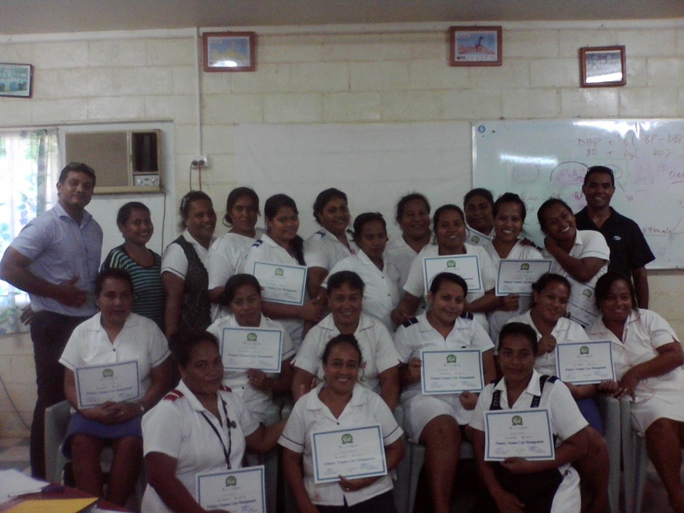
Betio PTC 1 Participants with their certificates after successful PTC completion with Instructors

- PTC Provider Course 2 : 26th – 27th June

The course was delivered over two days on Friday 26th June and Saturday 27th June 2015 from 0830 to 1630 hrs. Course contents were delivered using the participant manual, lectures using PowerPoint overhead projector, whiteboard presentations, demonstration scenarios, case scenarios, skill stations and workshop discussion groups. See detail programme in Attachment 5. The participant manuals were delivered to the participants a day prior to the courses.
PTC Multiple Choice Questions

The PTC course was evaluated using a standard multiple choice questions related to trauma assessment and management before and after the course. There were 20 questions delivered on the PowerPoint projector and the participants were given papers to write their answers with their names pre and post PTC course delivery respectively. The answers were then analysed to ascertain the baseline knowledge as well as the gain from the course.
 | Range |  | Average |  | Mode |  | Poorly scored Question |  | Highly scored Question
MCQ | Pre | Post | Pre | Post | Pre | Post | Pre | Post | Pre | Post
Scores | 1-16 | 10-20 | 8.3 | 17.9 | 8 | 20 | Q11 | Q12 | Q1 | Q20
Coloured=correct answers

Poorly scored questions

Q11. During transport a patient develops severe difficulty breathing, distended neck veins, diminished breath sounds on right, cyanosis, deviation of trachea to the left and vital signs: BP 90/60, RR 36 and HR 130; Which of the following is the most appropriate next step?
a. Intubate the patient
b. Needle decompress right side
c. Insert bilateral chest drains
d. Perform a detailed examination
e. Start an intravenous line
Q12. The secondary survey;
a. Will identify haemodynamic instability
b. Looks for significant injuries that are not an immediate threat to life
c. Includes assessment of AVPU
d. Includes establishment of intravenous access
e. Should be carried out even if the patient is deteriorating
Highly scored questions
Q1. Primary survey should be performed
a. After secondary survey
b. After rapid ambulance transfer of the patient to a Central hospital
c. Only at the Central hospital and not at the District hospital
d. Within 2 to 5 minutes
e. Within 30 minutes
Q 20. Tracheal intubation must be considered when there is a need to
a. Secure an open airway
b. Establish haemodynamic stability
c. Stabilise a cervical fracture
d. Treat a tension pneumothorax
e. Improve peripheral oxygenation in a spontaneously breathing patient

Participants
There were total of 25 participants, comprising of 20 final year Nursing Students, from KSON, and 5 Nursing officers from Betio Hospital. The participants made their own way each day to attend the course. All the participants turned up with great enthusiasm from the beginning and continued their momentum till the last day and wanted more. All participated well in the workshops, case scenarios and skill stations.

There was avenue provided for them to share their experiences of how they managed certain situations and the difference it would have made had they attended the PTC courses earlier. Participants were divided into 3 groups for the practical sessions according to their level of training.

Course feedback was very positive. Many felt the course was very relevant to their current practice. It was an excellent course that made them felt more confident to handle seriously injured or critically ill patients. As anticipated, many expressed that two days for PTC was inadequate to fully appreciate the course contents.
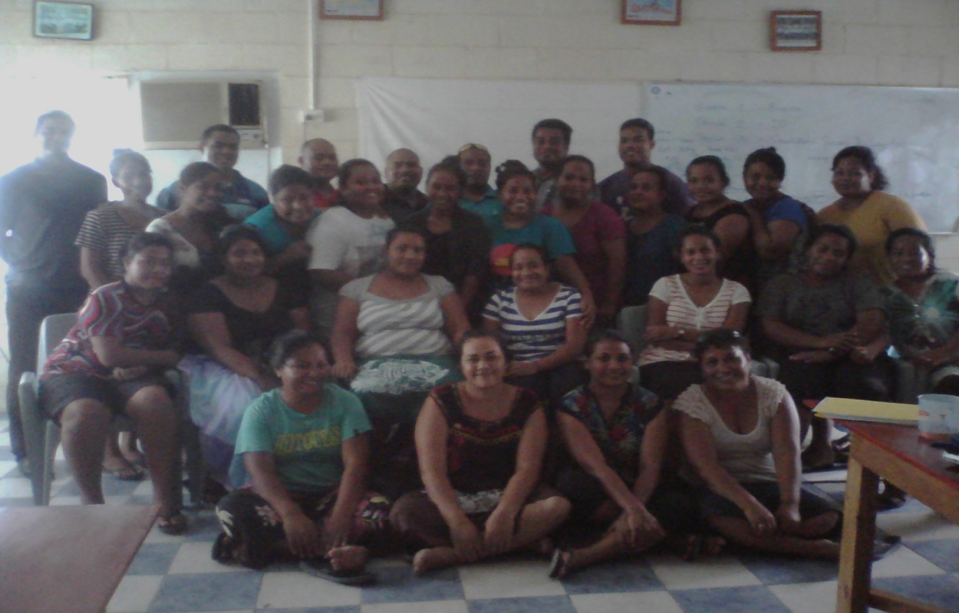
Betio PTC 2 Participants with certificates after successful PTC completion with Instructors

- Administration Support

The MHMS were very supportive in arranging transport to and from for the participants every day. The Betio Town Council provided the venue and funding for the courses were provided by KITP & MHMS.

- Venue

The courses were conducted in the conference room at the Betio Town Council Hall

- Transport and Accommodation

The instructors were given the KITP car for their transport and 2 of the External Instructors were accommodated at TADS guest house while the other was a local who was accommodated at her home but was picked up and dropped off for the course duration. The other instructors made their way to the training venue each day and dropped off.

- Dilemmas

We had late starts on all the day due to power outage due to road construction and we had to source and secure a generator from a local resident which was used for the 4 days (2 PTC courses). We had to purchase 20 dollars (AUD $20.00) of fuel each morning to run the generator to power the lap top, multimedia and the split air-condition for the duration of the 2 PTC courses. All the days were started late at 9.30am due to poor road conditions making participants and instructors arriving late and town council not starting the generator prior to the arrival of instructors and participants. The Town Council who promised to provide us with the multimedia failed to do so but thank you to the Town Mayor who provided his multimedia for the first day then Odylia from TCH organised one from KSON for the remaining days. The tea was not on time especially the afternoon teas.

- Summary

There was evidence in the above results together with feedbacks and performances during discussion, skill stations and workshops that the PTC Gospel was well taken. The participants were very enthusiastic from the start to the end and still were hungry for more and requested if all staff member in their facilities could be trained.
- Conclusion

There were Two (2) Primary Trauma Care Provider courses were delivered in Betio for the nurses from Betio Hospital and the final year trainee nurses. The courses were well received and appreciated by the participants and the facilitators. Most participants felt very comfortable with the hands-on approach, hence the practical sessions and discussions proved to be worthwhile minus the time constraints.

SOUTH KIRIBATI HOSPITAL COURSES

Report compiled by Dr Alani Tangitau
Instructors:
Drs Alani Tangitau, Titai Naitoa, SNO Arite Tetoa, NO Teitinana Ribanti
The SKH team had to take an early morning 1hour and 15 minutes flight from Tarawa to Tab North on Wednesday, 24th June.
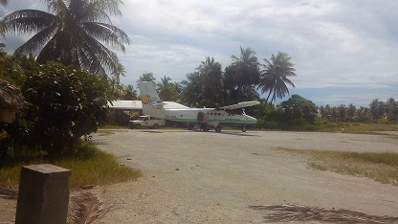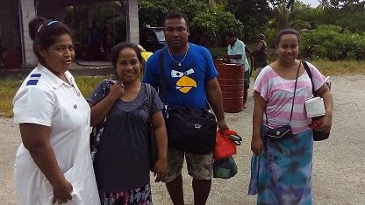
South Kiribati Hospital PTC Team arrival at Tab North airport

This PTC course was the 1st ever training to be conducted in SKH and this is quite an achievement for the MHMS. It was a two 2-day PTC courses and the participants were from wide range of health speciality (clinical nurses, public health nurses, doctors and medical assistant). There were 23 participants on the 1st PTC course for SKH. The majority of the staff involved were staff nurses from the Emergency, Operating Theatre, General Ward and Public Health. (Participants list – Attachment #)
On the morning of the first day of the course the Sister in charge at SKH, welcomed the participant and instructors and one of the participants led us with a prayer. The Doctor in Charge at SKH, Dr John Tekanene, kindly allowed us to use the Children Ward at SKH for the courses as there were no patients at the time. Program for the course was based on the schedule in the PTC Teaching Resources Manual.
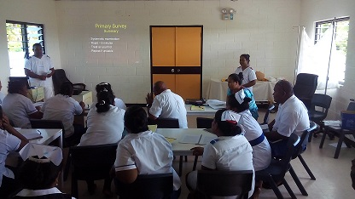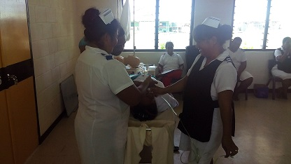
All of the power point presentation was done in the morning sessions before lunch and slides were in English while the discussion and facilitators were mostly in I – Kiribati language. Skill Stations, workshops and scenarios were done after lunch
Multiple Choice Questions (MCQs)
South Kiribati Hospital Course

Participants did the multiple choice questions at the beginning of the 1st day and at the end of the 2nd day. Results are summarized on the tables below

Table 1 : Participants marks in their multiple choice pre & post – test
Scores | <10 | 10-12 | 13-15 | 16-18 | 19-20 | Range
Pre test | 75% | 15% | 10% | - | - | 2 – 15
Post test | 11% | 22% | 56% | 11% | - | 8 – 18

Table 2 : Number of Participants with their increase scores between pre & post - test
Increase in scores | < 5 marks | 5 – 10 marks | >10 marks | Range
% Participants | 35% | 53% | 12% | 0 – 11

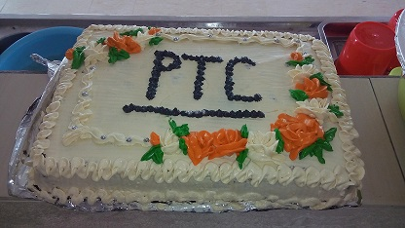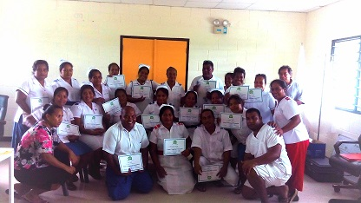

TIME FOR CELEBRATION!!!!!!

At the conclusion of the 2 days course at SKH, all the 23 participants received their certificates as well as Instructors gaining great experience from this 1st ever PTC course to be held outside of Tarawa.

Challenges
- Lack of basic resources especially equipment especially cervical collar therefore we adjusted our skill station to include other options of immobilizing the cervical spine.
- Isolation of the SKH and the lack of continuous medical education for the health staff
- Lack of training facilities therefore the team has to take their own laptop, projector and manikin for the PTC course.
- Since the majority of the participants are nurses, clinical & public health, therefore we tailored our discussion to their level taking into consideration what is available in their own settings. The main aim was to stabilize trauma patients and get help from the hospital as soon as practicable.
- Language : the use of I – Kiribati language during presentation & discussion thus create more interactive discussion while the slides were in English, as this make it easier for the participants to understand the concepts & contents of the course easily.

RECOMMENDATION

Annual PTC courses
- Target Participants
- Final Year Trainee Nurses : For KSON to confirm that this will be a compulsory requirement
- Doctors : All Interns and Doctors must do this course as part of their professional development – MHMS & Medical Council to confirm that this is a compulsory required for all doctors practice in Kiribati as part of their annual registration
- Nurses : That all nurses at MHMS must do this course – target for every nurse to attend this course in the next 2 years
- First Responders : That ambulance driver, police and fireman should be trained using an adjusted PTC course to suit their level of medical knowledge.
- Kiritimati Island PTC Course
Coordinating Team will confirm the plan for Kiritimati Island course and we hope to do this before the end of 2015.

- Local PTC Instructors
- With our current number (13) of local instructors, Kiribati can be able to run their own PTC course with minimal assistance from external Instructors, therefore for sustainability purposes, Instructors course should be done on an biannual basis to ensure that the number of local instructors are maintained.

- Kiribati PTC Coordinating Team
- The coordinating team to continue to work together with the MHMS and KITP in planning & delivering of PTC courses in Kiribati

- Sub-regional PTC course
- Kiribati is ready to provide PTC courses to it’s neighbouring countries – Nauru & Marshall Islands – taking into consideration the number of local Instructors available as well as the flight schedule between these 3 countries thus making travel arrangement easy to arrange.

CONCLUSION

At the end of this PTC course training, MHMS Kiribati has 13 PTC Instructors and we have trained 99 participants from various health background ranging from Intern doctors, clinical nurses, public health nurses , medical assistant and an ambulance driver.

This is quite an achievement for the KITP & MHMS, and we need to work together to progress and implement the recommendations and target for PTC in Kiribati as well as the other neighbouring Northern & Central Pacific.

Overall, let’s congratulate ourselves for a work well done and hope that we continue to spread the gospel of PTC not only in Kiribati but throughout the Pacific Islands & Territories.

Acknowledgements
Thanks to the Permanent Secretary for Health, Dr Teatao Tiira, and the Director of Hospital Services, Dr Burentau Teriboriki, for their support with the Ministry of Health. We also acknowledge the support from the OIC, Dr John Tekanene, and the Sister in charge, Kanrunga Mwemwe, at SKH, SNO Betio, Terry Eromanga, and PNOs. A special thank s to the instructors teams, Team TCH, Team Betio and Team SKH who all willing to assist us on our first ever PTC course in SKH & Betio as well as the instructor’s refresher course. Congratulations to all the local participants for their keenness and enthusiasm during the training.

The PTC course was co-funded by the Ministry of Health & Medical Services (MHMS), WHO and the Kiribati Internship Training Program (KITP), and we thank you so much for making it possible to deliver these 5 courses in Kiribati within a week period.

Last but not the least, our sincere thanks to Odylia Teaero, KITP Program Assistant for her tireless assistance with the organizing and sorting out the logistic needs for all the teams in 3 different locations running PTC courses simultaneously and you have been wonderful.

Congratulations to all and keep up the excellent work by all teams.

Attachment 1 : Kiribati PTC Course Program
- TARGET
- 1 Instructors Refresher Course (23rd June)
- 1 Course for South Kiribati Hospital (25th – 26th June)
- 2 Course for Betio Hospital (24th – 25th)
- 1 for Betio Nurses & MAs (24th – 25th)
- 1 for the final year Trainee Nurses [20] (26th – 27th)
- 2 Courses for TCH
- 1 for Interns & Nurses (24th – 25th)
- 1 for the final year Trainee Nurses [20] (26th – 27th)

- TENTATIVE SCHEDULE FOR TCH, BETIO & SKH
Date | ACTIVITIES
Monday  22nd June | Arrival of Instructors Team from Fiji  - Dr Desmond Aisi (PNG)  - Dr Hilda Schultz (Fiji)  - Dr Deepak Sharma (Fiji)
Tuesday  23rd June | Instructors Refresher Course  Venue : Taiwan Building Ground Floor  Time : 0900 – 1600hrs  Participants : 10 (4 doctors, 3 KSON Tutors, 3 Senior ED Nurse)  Facilitators : 6
Wednesday  24th June | Tungaru Team  Course 1 (Wed & Thurs)  Participants : Interns & Nurses (20) | Betio Team : MHMS  Course 1 (Wed & Thurs)  Participants : Nurses, Medical Assiatant (20) | SKH Team : MHMS  Fly to Tab North
Thursday  25th June |  |  | SKH Course (Thurs & Fri)  Participants : Nurses & Medical Assistant (25)
Friday  26th June | Course 2 (Fri & Sat)  Participants : Final Year Trainee Nurses [20] | Course 2 (Fri & Sat)  Participants : Final Year Trainee Nurses [20]
Saturday  27th June |  |  | Return Flight from Tab North
Dinner at Tabontekeeke Resort and Award Instructors’ Certificate
Hosted by KITP & MHMS
Sunday  28th June | FREE DAY
Monday  29th June | Departure of Team from Tarawa

Attachment 2 : Instructors Course Participants List
Participants
- Dr Thomas Russell – Intern
- Dr Ieita Atanrerei – Internal Medicine Registra
- Dr Titai Naitoa – Intern
- Dr Bukitua Teuea – Intern
- Tatiku Kabuati – KSON [Did not attend]
- Monica Tarabo – KSON
- Maile Kiritome – KSON
- SNO Teiraoi Bio – Emergency Nurse
- SNO Arite Tetoa – Emergency Nurse
- Teitinana Ribanti – Emergency Nurse
Facilitators
- Dr Desmond Aisi
- Dr Deepak Sharma
- Dr Hilda Schutz
- Dr Tekeua Uriam
- Dr Kabiri Tuneti
- Dr Alani tangitau

Attachment 3 : Instructors Course Program
Tuesday 23rd June, 2015

8.15 Registration and welcome

8.30 Introduction to the day and our training methods

8.45 SESSION 1: How to improve your communication skills – Dr Alani

9.45 SESSION 2: How to be an interactive instructor – Dr Tekeua
Part 1: How to prepare and ask good questions
Part 2: How to prepare and lead PTC Workshops

10.45 Refreshments break

11.15 SESSION 3: How to run scenarios – Dr Hilda

12.30 Lunch

13.15 SESSION 4: How to run the skill stations – Dr Desmond

14.15 SESSION 5: How to run a PTC course – Dr Kabiri
General information
Planning the follow-on 2-day course

14.50 Refreshments break

15.00 SESSION 6: How to give a good PTC lecture – Dr Deepak
Part 1: How to use slides effectively
Part 2: How to deliver a good lecture

16.40 Confidence Matrix
Instructor day evaluation

17.00 Finish

Attachment 4 : Participants List = 99

Tungaru Central Hospital |  | Betio Hospital |  | South Kiribati Hospital
Course 1 | Course 2 | Course 1 | Course 2
T Renata [OT Nurse] | T. Amten [TN] | B Amon [NO] | S Salona [TN] | K Mwemwe [SNO, SKH]
N Tion [OT Nurse] | T. Tuneti [TN] | N Airam [NO] | O Eriuta [TN] | R Kautea [SKH]
A Mwea [ED SNO] | T. Itaea [TN] | T Karakaua [NO] | K Naibobu [TN] | E Tataio [SKH]
R Kanaua [ED SNO] | T. Temokou [TN] | N Kautune [NO] | K Ngauea [TN] | T Bateriki [SKH]
T Anrake [PNO] | T. Obeta [TN] | N Teraoi [NO] | M Tekaiwa [TN] | E Bokai [SKH]
W Tiare [EDNurse] | R. Beretiata [TN] | A Teariki [NO] | E Irooti [TN] | N Teawe [SKH]
Interns | R. Bwatiku [TN] | K Nikora [NO] | S Romano [TN] | E Aboro [SKH]
Dr R Waitea | T A Rui [TN] | T Kaitiroa [NO] | T Terinan [TN] | T Iareto [SKH]
Dr R Tekobea | T. Mikaere [TN] | K Bainere [MA] | T Moote [TN] | T Tearoua [SKH]
Dr A Rutio | J. Naare [TN] | T Irata [MA] | T T Namane [TN] | T Tokataake [MA, PH]
Dr T Nauto | T. Tekitau [TN] | B Kannangaki[NO] | T Aberaam [TN] | N Teitibong [PH Nurse]
Dr A Kauongo | A.Teiwaki [TN] | R Tikataake [NO] | T Baikitea [TN] | A Etera [PH Nurse]
 | B Orive [TN] | T Katarake [NO] | T Alanrika [TN] | T Tariu [PH Nurse]
 | M Baretarawa [TN] | M Tong [NO] | F Beiatau[TN] | K Tabuia [PH Nurse]
 | M Ioane [TN] | S Tebabua [NO] | T Bakoaun [TN | T Bakanebo [PH Nurse]
 | O Tamoaieta [TN] | N Tebaubau [NO] | T Rimon [TN] | A Aree [PH Nurse]
 | R Bouanteraoi [TN] | M T. Neemia [NO] | T Iote [TN] | I Tataua [PH Nurse]
 | T Etuati [PNO] | T Eromanga [NO] | S Serettanaia [TN] | R Korauaba [PH Nurse]
 | B Williams [ED NO] | K Temake [MA] | K Timeon [TN] | K Korauaba [PH Nurse]
 | T Uakeia[ED Nurse] |  | B Eric [Betio Nurse] | Dr A Mareko [OT]
 |  |  | E Etera [Betio Nurse] | Dr T Temboa[Medicine]
 |  |  | F Hopi [Betio Nurse] | Dr J Tekanene [GMO]
 |  |  | T Taiaa [ED Nurse]
 |  |  | K Kaitu [SKH Nurse] | T Batinana [A Driver]
 |  |  | T Tekataba [EDNurse]
12 | 20 | 19 | 25 | 23
TOTAL PARTICIPANTS : 99
Key
SNO : Senior Nursing Officer
NO : Nursing Officer
TN : Trainee Nurse
MA : Medical Assistant
PH : Public Health
ED : Emergency Department
SKH : Southern Kiribati Hospital
OT : Operating Theatre

Attachment 5 : Betio PTC Course Program

DAY 1
TIME | TOPIC | INSTRUCTOR
0800-0900 | Set Up/Arrival of Participants | Team
0900-0940 | Registration/Introduction/Pre PTC MCQ | Desmond
0940-1000 | Local Trauma Perception | Hilda
1020-1040 | ABCDE of Trauma and Primary Survey | Hilda
1040-1120 | Airway and Breathing | Maile
1120-1200 | Circulation and Shock | Monica
1200-1240 | LUNCH BREAK
1240-1300 | Demonstration Scenario- Bad and Good | Team
1300-1330 | Chest Injuries | Ieata
1330-1350 | Abdominal, Pelvic and Limb Injuries | Hilda
1350-1420 | TEA BREAK
1420-1600 | Skill Stations  - Open/Tension Pneumothorax- Needle DC & 3-seal dressing /Pelvic Strapping  - Primary Survey Scenario  - C Spine Inline Immobilisation/Log Roll | Desmond/Maile  Hilda  Ieiata/Monica
1600-1630 | Overview and Summary | Desmondi/Team

DAY 2
TIME | TOPIC | INSTRUCTOR
0800-0930 | Registration/Set Up | Desmond/Team
0930-1030 | Head and Spinal Injuries | Hilda
1030-1130 | Trauma in Children and Pregnancy | Desmond
1130-1230 | Burns | Ieiata
1230- 1330 | LUNCH BREAK
1330-1500 | Skill Stations and Workshops  - Basic/Advanced Airways  - Circulation- Intraosseous Cannulation  - Burns Workshop | Hilda/Maile  Desmond/Monica  Ieiata
1500-1515 | BREAK
1515-1550 | Secondary survey | Maile/Monica
1550-1650 | Disaster Management | Desmond
1650- 1710 | Repeat MCQ Post PTC | Desmond
1710- 1800 | Overview and Summary/Evaluation/Certificate Presentation | Desmond/Team

